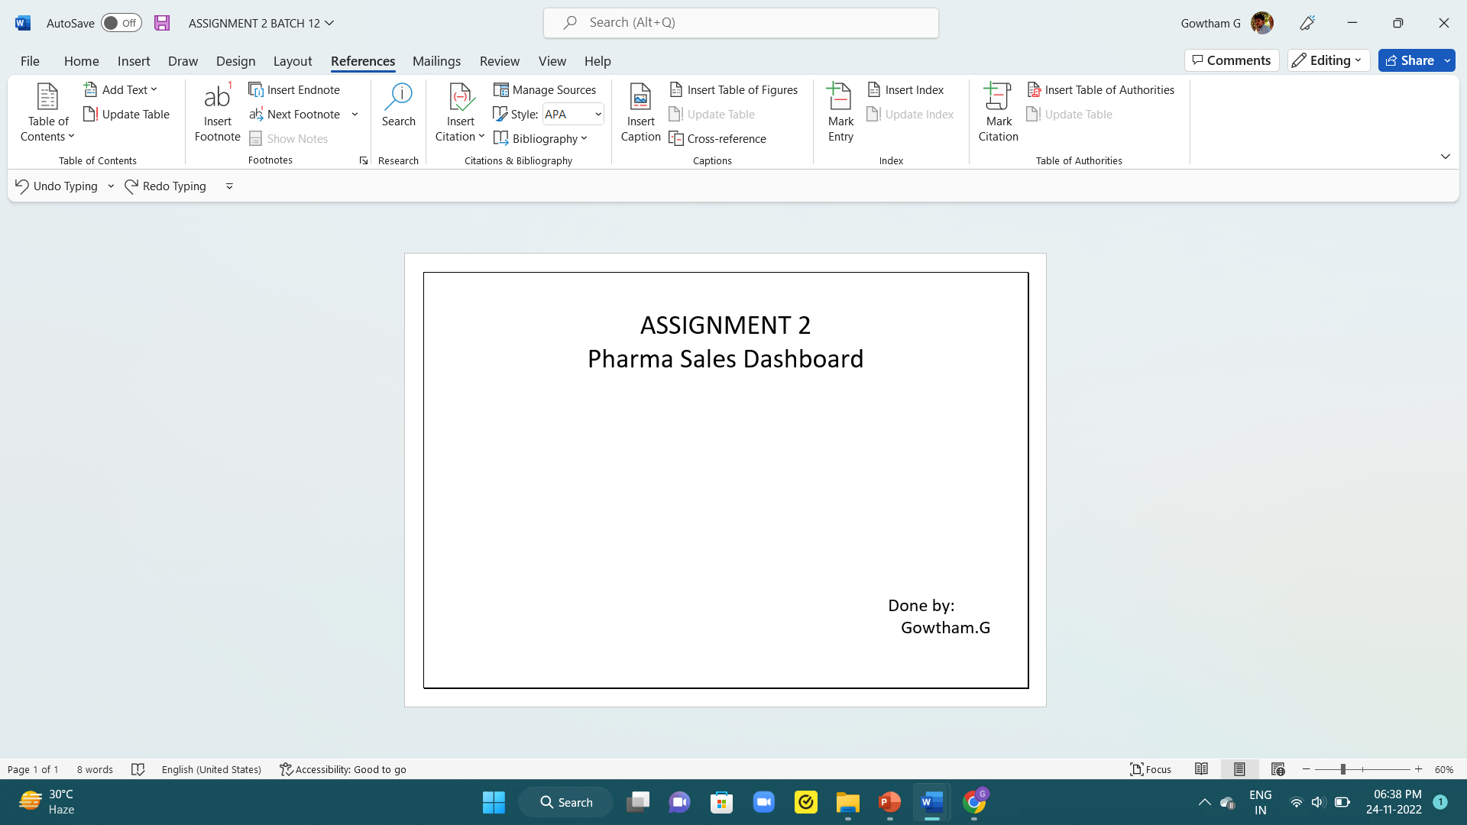



 Challenge:-

1.Sales By Customer. 

2.Sales By Location.

3.Sales By Sales Representative. 

4. Received Inventory From Supplier

5. Inventory Stock for Warehouse Locations

6. Sales Trend

7.Monthly Sales

8. Actual and Received Inventory by Month



Sales By Customer

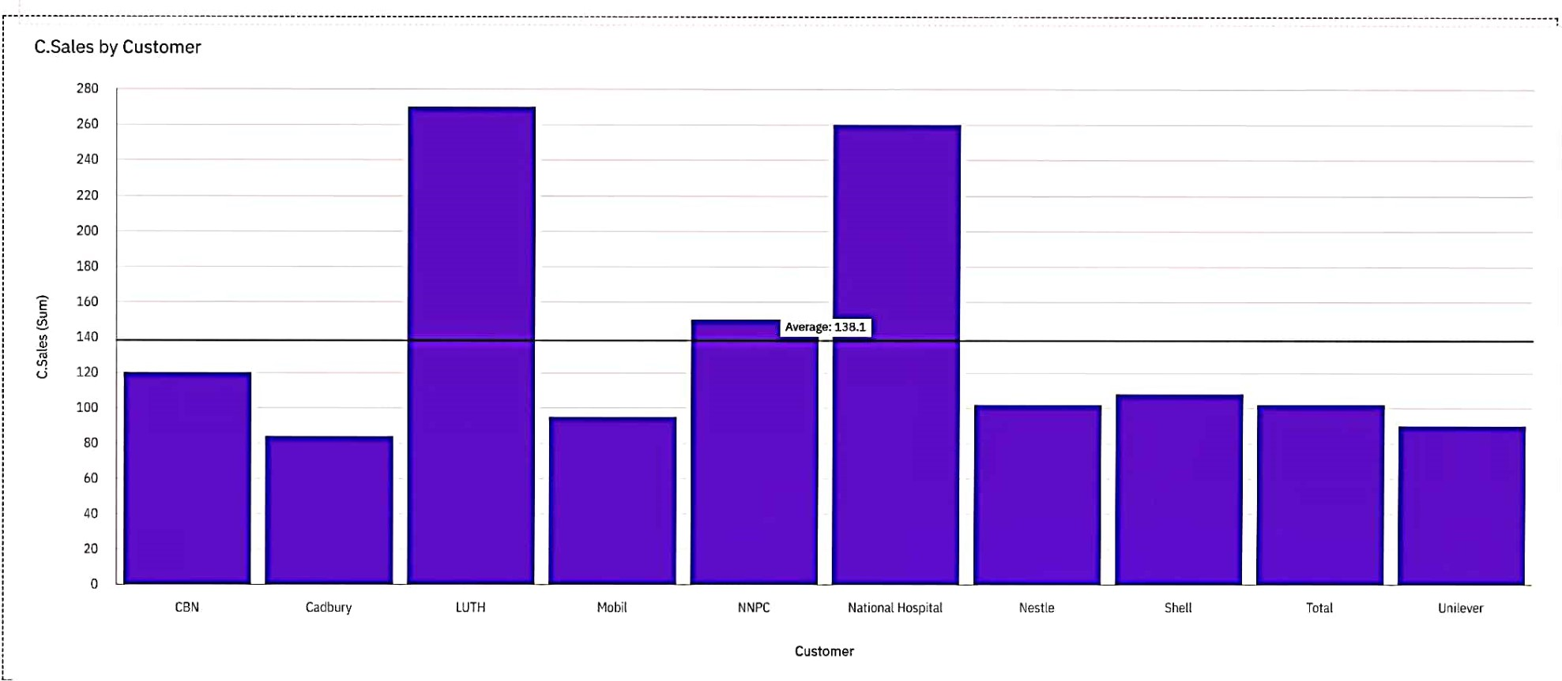C.Sales by Customer

280

260

240

220

200

180

160

8 140

120

100

80

60

40

20

CBN Cadbury LUTH Mobil NNPC National Hospital Nestle Shell Total Unilever

Customer

Sales By Location

L.Sales for Location regions

L.sales (sum)



14.6 260

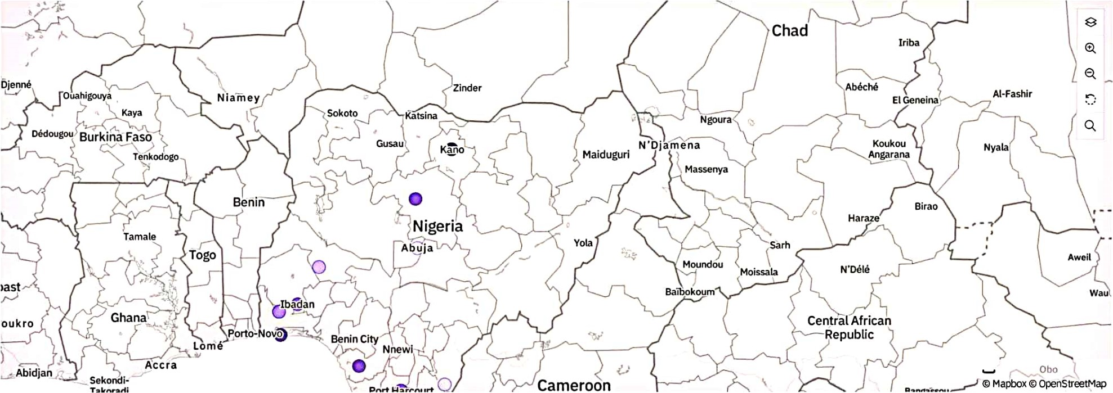

s a Les By Sales Representative

Sales by Sales Rep

700

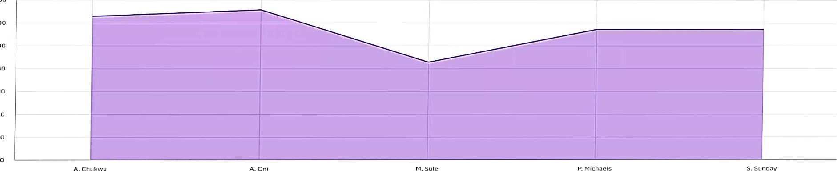600

500

400

8

300

200

100

Sates Rep



Received Inventory F rOlTl Supplier

Received Inventory by Supplier sized by Received Inventory

Received Inventor.„

o

|  |  |  |  |  |  |  |
| --- | --- | --- | --- | --- | --- | --- |
|  | -o |  |  |  |  |  |
|  |  |  |  |  |  |  |
|  |  |  |  |  |  | |
|  |  |  |  |  |  | |

650,000

Sanofi

Pfizer

Novartis

Astra Zeneca

300,000 350,000 aoo,ooo

450,000 500,000 550,000 600,000 650.000 700,000

Received Inventory (Sum)

# Inventory Stock for Warehouse Locations

Warehouse Locations for Inventory Stock

Column values

OIncrease Decrease sum

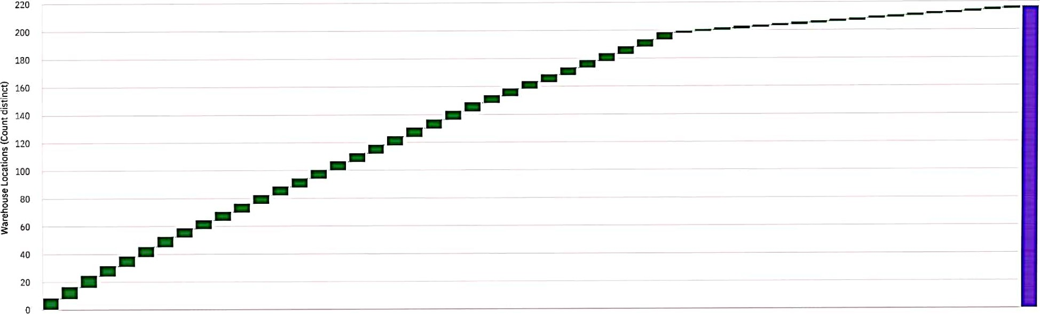

240 600 960 1,320 280 420 660 980 1.400 1,750 2,800 3.850 200 350 500 800 1,100 19.0B 44.07 69.06 94.05 119.03 144.02 169.01 194 213.99

480 840 1,200 120 300 560 700 1,120 1,540 2.450 3,500 100 250 400 550 1,000 6.59 31.58 56.56 81.55 106.54 131.53 156.52 181.5 206.49 sum

Inventory Stock

# Sales Trend

L.Sales, C.Sales, M.Sales and Rep.Sales by Month

Measures

L.SalesC.Sales O M.Sales oRep.Sales

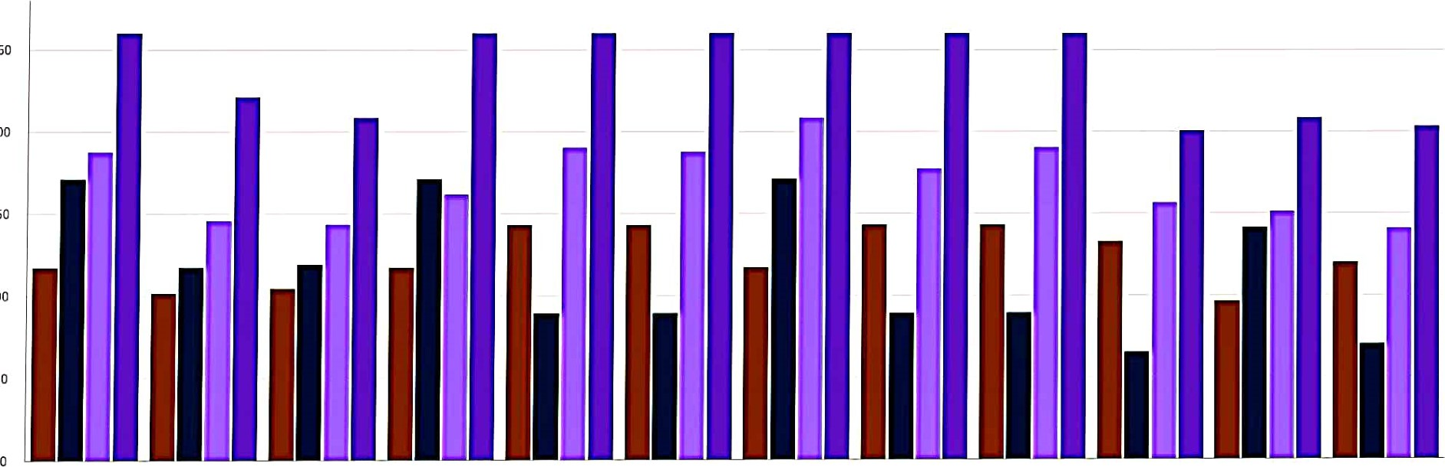

250

50

200

v, 150

2

100

April August December February January November October September

July June March May

Month

# Monthly Sales



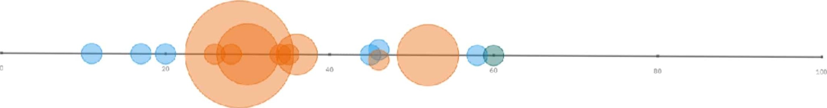

me&tive st'e-8th

## Actual and Received Inventory by Month

Actual and Received Inventory for Month

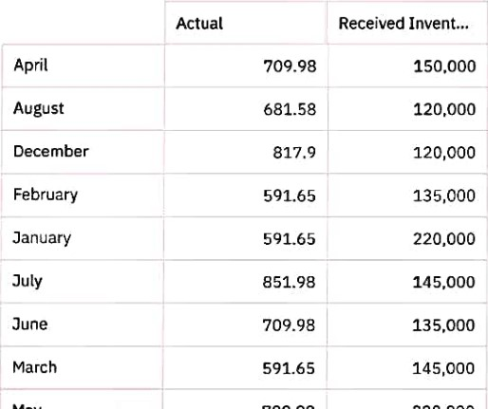

•no

00

"on

nnn